Created basic iflow
Have same 403 forbidden error
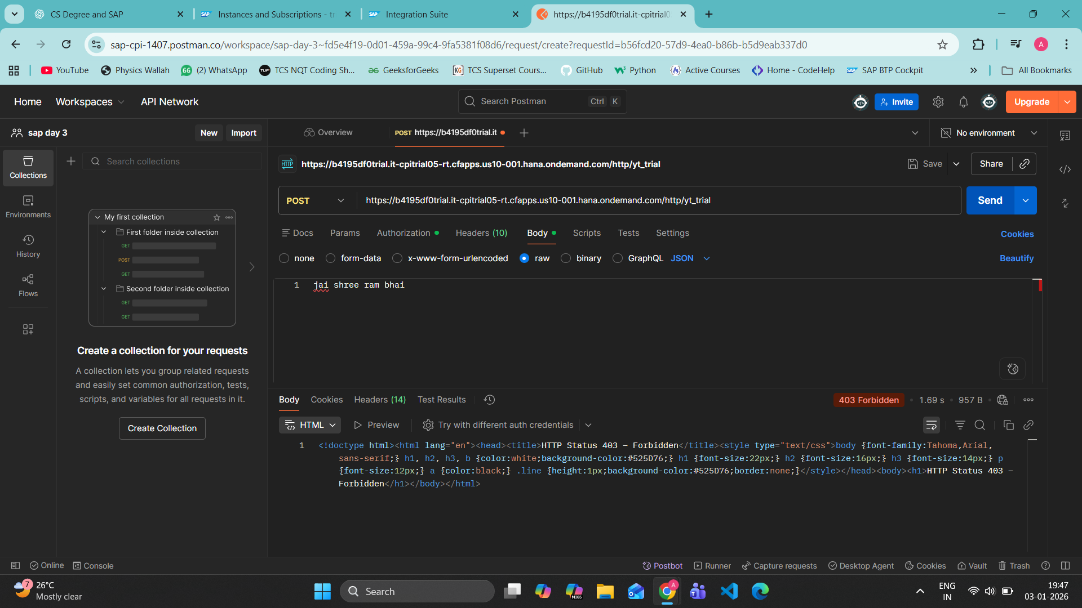
I unchecked this CSRF PROTECTED thing at bottom
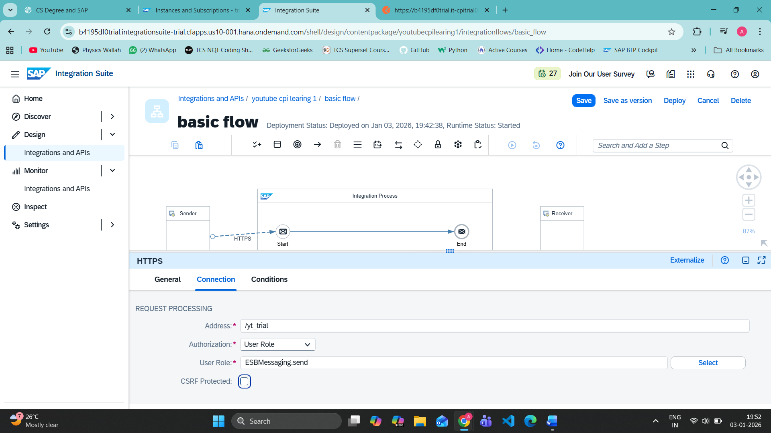

Our iflow carries message to CPI and returned back
Finally get something correct and working
